ABIRAMI K

230701008 CSE-A

EXP NO: 10

EXP 10A BEST FIT

PROGRAM

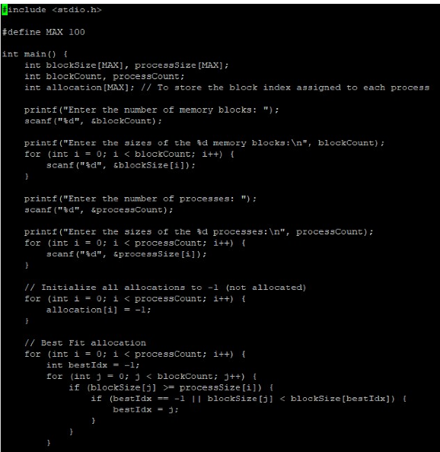

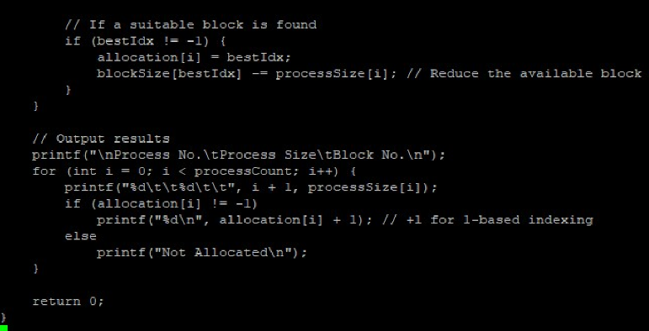

OUTPUT

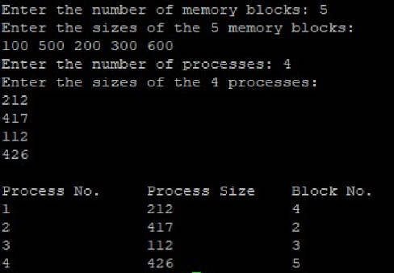

EXP NO: 10B BEST FIT

PROGRAM

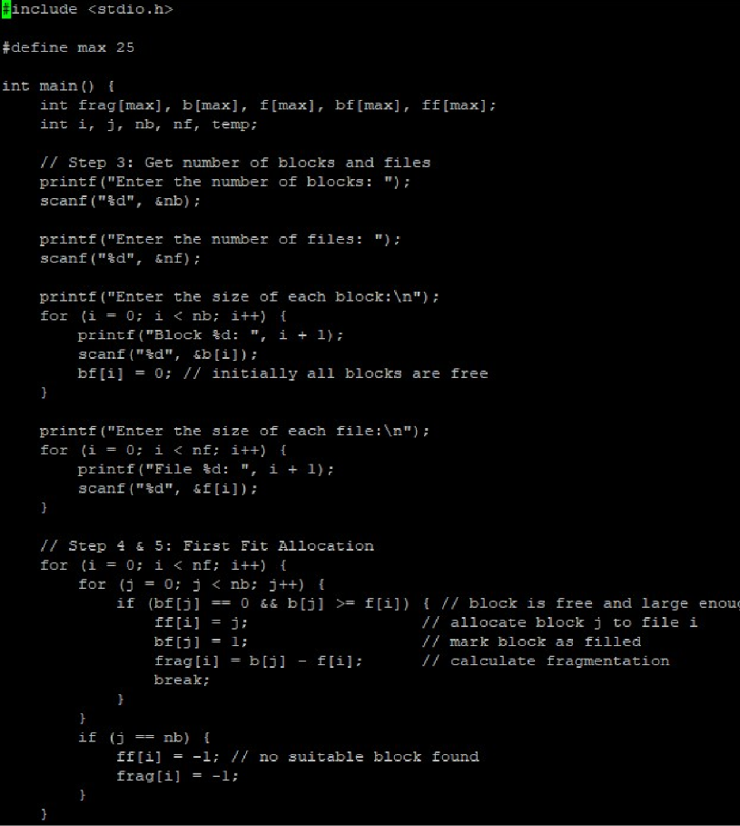

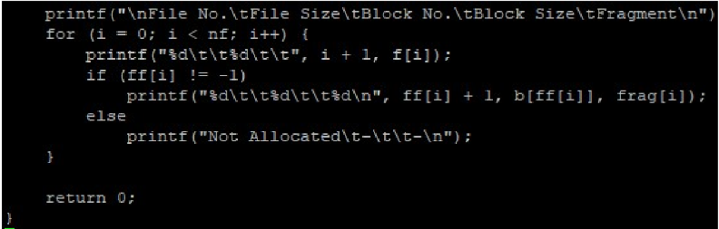

OUTPUT

